COMPUTER ASSIGNMENT.

2.2 P-85

The code

clear all

% Generate mean vectors.`

m1 = [1;1];

m2 = [8;6];

m3=[16,1]';

% Define the covaraince matrix.

S = [4 0; 0 4];

s(:,:,1) =S;

s(:,:,2) =S;

s(:,:,3) =S;

m=[m1, m2, m3];

% Generate 1000 random variables from a given mean vectors from 3

% equiprobable cases.

[X, y]=genGaussClasses(m,s,[1/3 1/3 1/3],1000);

x1 = X(:,1:2:end)

x2 = X(:,2:2:end)

XX(:,1) = reshape(x1,999,1);

XX(:,2) = reshape(x2,999,1);

XX=XX';

% Perform classifications.

bayes = bayes_classifier(m,s,[1/3 1/3 1/3],XX);

euclid = euclidean_classifier(m,XX);

maha = mahalanobis_classifier(m,XX,s);

% Classification Errors in percentage.

errBayes = class_error(y,bayes)/10

errEuclid = class_error(y,euclid)/10

errMaha = class_error(y,maha)/10

Result:

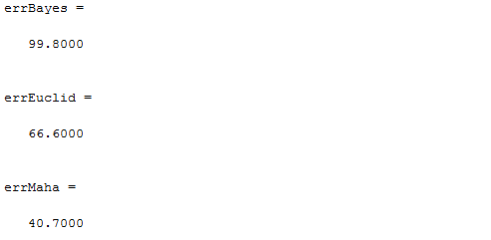

Note: The functions used above, like genGaussClasses(m,s,P,N) etc., are provided in the prescribed text book from pages 79 to 84.